**Data Flow Diagrams**

**Level 0- Context diagram for Zoo Information management System**

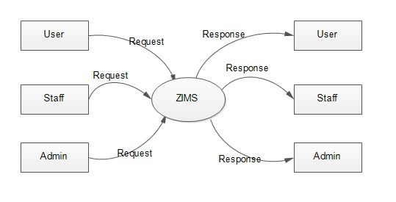

**Level 1 DFD for Admin**

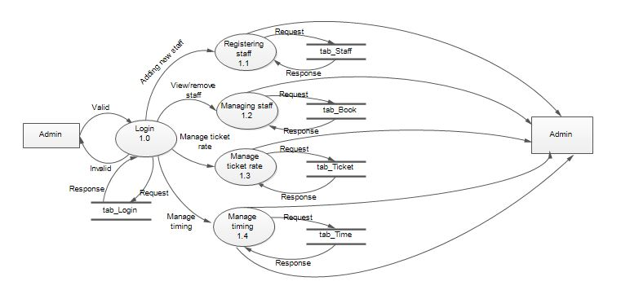

**Level 1 DFD for Staff**

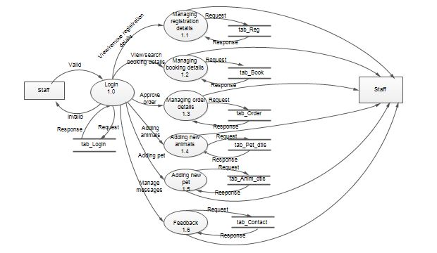

**Level 1 DFD for User**

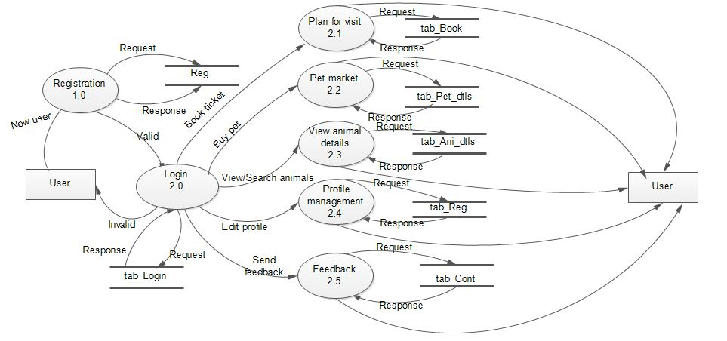

**Level 2 DFD for User- Plan for visit**

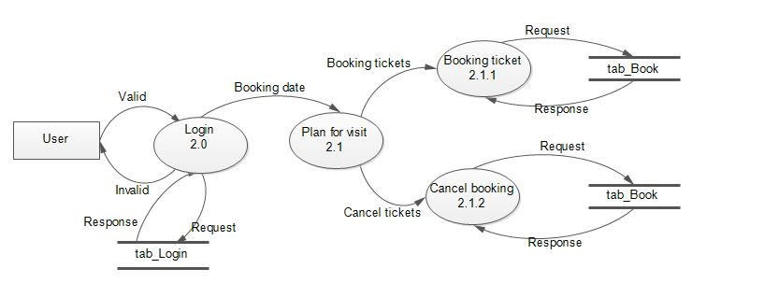

**Level 2 DFD for User- Pet market**

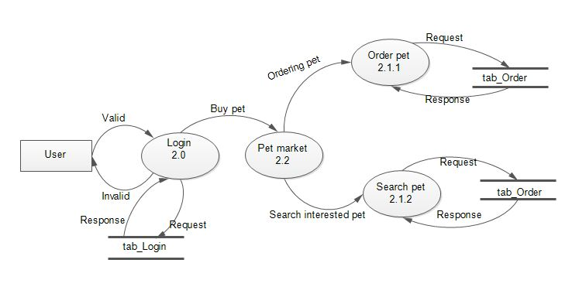

**Level 2 DFD for Staff- Booking details**

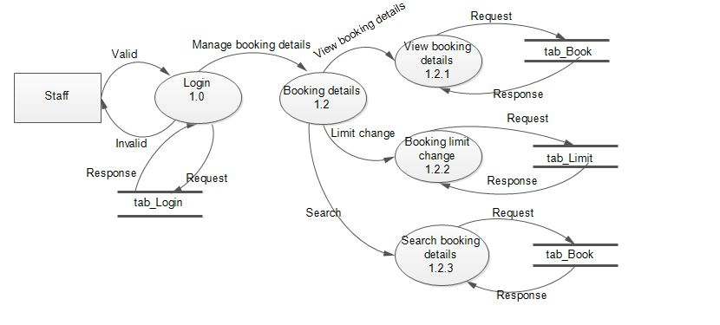

**Level 2 DFD for Staff- Order details**

